Computational Physics Exercise 4

# an orbiting probe

In this first part, I will attempt to simulate the orbit of a probe around the earth. I assume that the probe has negligible mass and hence the Earth will remain totally stationary. The equation we are trying to solve is:

Where *M* is the mass of the earth, *m* is the mass of the probe, *r* is the distance between them and *G* is Newton’s gravitational constant. I set the origin to be at the centre of the earth and assumed the probe would move in a plane; ie the problem could be simplified to a 2D case. I will use the Runge Kutta method to solve the problem. I have 4 variables: x, y, velocity in the x direction (vx) and velocity in the y direction (vy). Using equation 1, I can distill 4 functions, and hence I will be able to solve the problem:

|  |  |  |  |
| --- | --- | --- | --- |
|  |  |  |  |

Where the square brackets denote functions of t, x,y, vx and vy. Each function corresponds to a different variable and each will be solved separately using runge-kutta. For example, for x, the k values will be:

|  |  |  |  |
| --- | --- | --- | --- |
|  |  |  |  |

Where ***z*** denotes each of the variables. Hence the new value for x can be calculated:

The other k values all depend on a specific function:

|  |  |  |  |
| --- | --- | --- | --- |
|  |  |  |  |

Here the bold type denotes that there are in fact four *k* values for each variable. Having calculated the k values we can then calculate the new value of each variable similarly to how we calculated x:

Where ***a*** can be replaced with each variable.

I have written a program that simulates a small probe being affected by Earth’s gravity. It calculates using a timestep of one minute and the simulation runs either for 10 days or until the probe crashes into the earth or returns to its starting position. Data from each calculation is outputted to a text file, and can then be plotted in order to see the path that the probe takes. Figure one shows the probe starting 10e6 metres away from the earth with a large velocity diagonally away from the earth. However, it is slower than the escape speed and hence we see the probe crash into the surface of the earth.

Figure 1: The probe crashing. Red circle is the earth.

Figure 2 shows an eccentric orbit created when the probe was launched with from (-7000000, 0) with velocity (0, 10500) m/s.

Figure 1: An eccentric probe orbit. Red circle is the earth

Figure 3 shows a circular orbit which was created when the probe was launched from (-7000000, 0) m with a velocity of (0, 7543.9) m/s.

Figure 3: A circular probe orbit. Red circle is the earth.

My program also calculates the energy of the probe by summing the gravitational potential and the kinetic energy of the probe at each timestep. I am interested in the conservation of energy, not the actual numbers and hence the mass of the probe is arbitrarily chosen to be 1. Figure 4 shows the kinetic and potential energy of the probe over time. All appears to be well; however the scale is distorting the information. Figures 5 and 6 give a better indication of what is occurring.

Figure 4: the kinetic and potential energy of the probe

Figure 5: potential energy of the probe

Figure 6: kinetic energy of the probe

We hope that the oscillations will cancel out when we calculate the total energy; however this is not the case, as can be seen in figure 7.

Figure 7: total energy of the probe.

The oscillations are dependent on the time increment used in the Runge-Kutta calculation. If a larger time increment is used then the frequency of the oscillations increases. Hence if a small enough time increment is used then it appears that the energy is merely increasing. In the long term energy **is** being conserved, but in the short term these oscillations are very frustrating. I hypothesize that these oscillations are due to repeated undershooting and overshooting in the Runge Kutta method.

# moon flyby

Secondly I attempted to simulate a probe being launched from earth, flying close to the moon (within 500km) and then returning to the Earth. To do this I added in a term to allow for the effect of the Moons gravity. I assumed that the earth was stationary relative to the moon. Our equation becomes:

The meaning of the various letters is explained by figure 4.

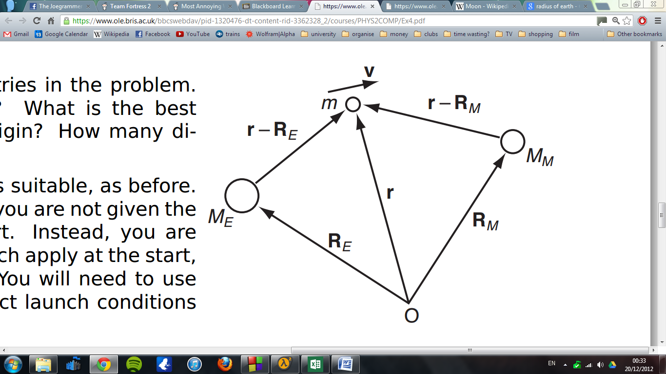

Figure 4: diagram of the situation.

Hence our functions become more complex:

We can simplify the situation by carefully choosing our co-ordinates. I choose the origin to be at the centre of the earth and hence RxE and RyE become zero. I set the moon to be on the x-axis and hence RyM becomes zero.

Our k’s can be calculated as before and I used the same time step as in problem 1. I added in a condition so that the simulation would also stop if the probe crashed into the moon. I found that if the probe was launched parallel to the y-axis with a speed of 10597.6m/s, then the orbit shown in figure 5 was produced. This orbit passes within 186 km of the moon and then returns to earth.

Figure 5: An orbit which passes close to the moon.

I also found that it was possible for the probe to travel in a figure of eight orbit. A plot of this is shown in figure 6, where the probe was launched (parallel to the y-axis) with a speed of 10584.8m/s.

Figure 6: A figure of eight orbit.

However this orbit does not pass very close to the moon. In order to get closer to the moon, a less symmetrical orbit is required:

Figure 7: path of the probe when launched parallel to the y axis with speed of 10590.05m/s.

For this orbit, changing the launch speed by just 0.1m/s will cause the probe to crash into the moon. Disappointingly, this orbit does not even pass very close to the moon: 2890km at its closest point. I have been unable to find a “figure of eight” orbit which passes sufficiently close to the moon.

# a two body problem

Finally I attempted to simulate the motion of two massive bodies, ie where they will both orbit around a common centre of mass. We therefore have two equations:

|  |  |
| --- | --- |
|  | (6) |
|  | (7) |

The meanings of the letters are explained in figure 7.

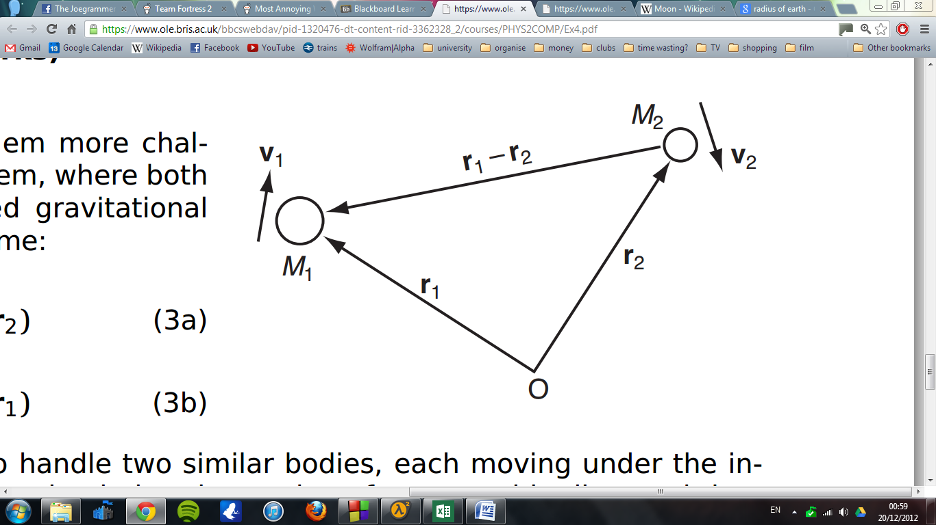

Figure 7: The names of the variables

For equation 6, our functions are:

|  |  |
| --- | --- |
|  |  |
|  |  |

For equation 7 our functions will be very similar, we will simply swap around the 1’s and 2’s. Hence in my program I used one set of functions and merely swapped around the arguments when calculating equation 7. I started the earth at the origin with a velocity of (0, -12.55). I started the moon at (385000000, 0) with an initial velocity of (0, 1022). These numbers were chosen such that that the earth and moon should orbit around their common center of mass. However unfortunately my program doesn’t work. Figure 10 shows a typical “orbit” my program produces. In fact, the moon does deviate slightly from a straight line, but it is as if gravity is extremely weak. I feel like I have checked my equations a million times, but I cannot find the error.

Figure 10. A demonstration of the failure of my final program.